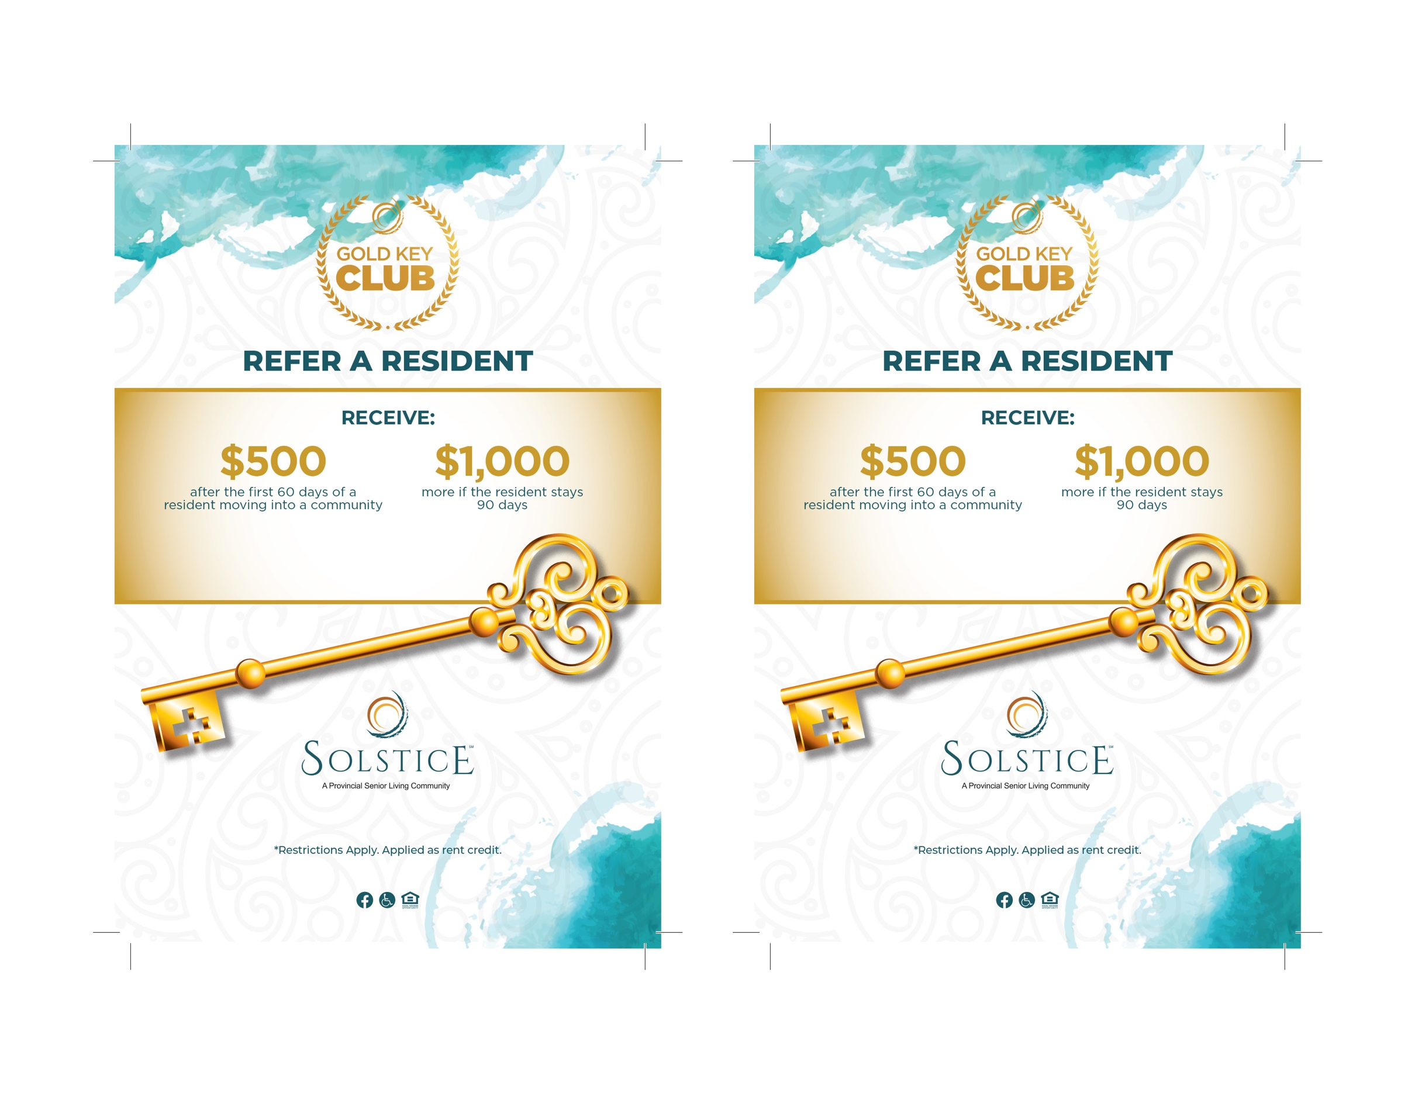
XXX Address Road • City, ST XXXXX
CommunityWebsite.com
XXX Address Road • City, ST XXXXX
CommunityWebsite.com
Call (XXX) XXX-XXXX
for more details.*
Call (XXX) XXX-XXXX
for more details.*

