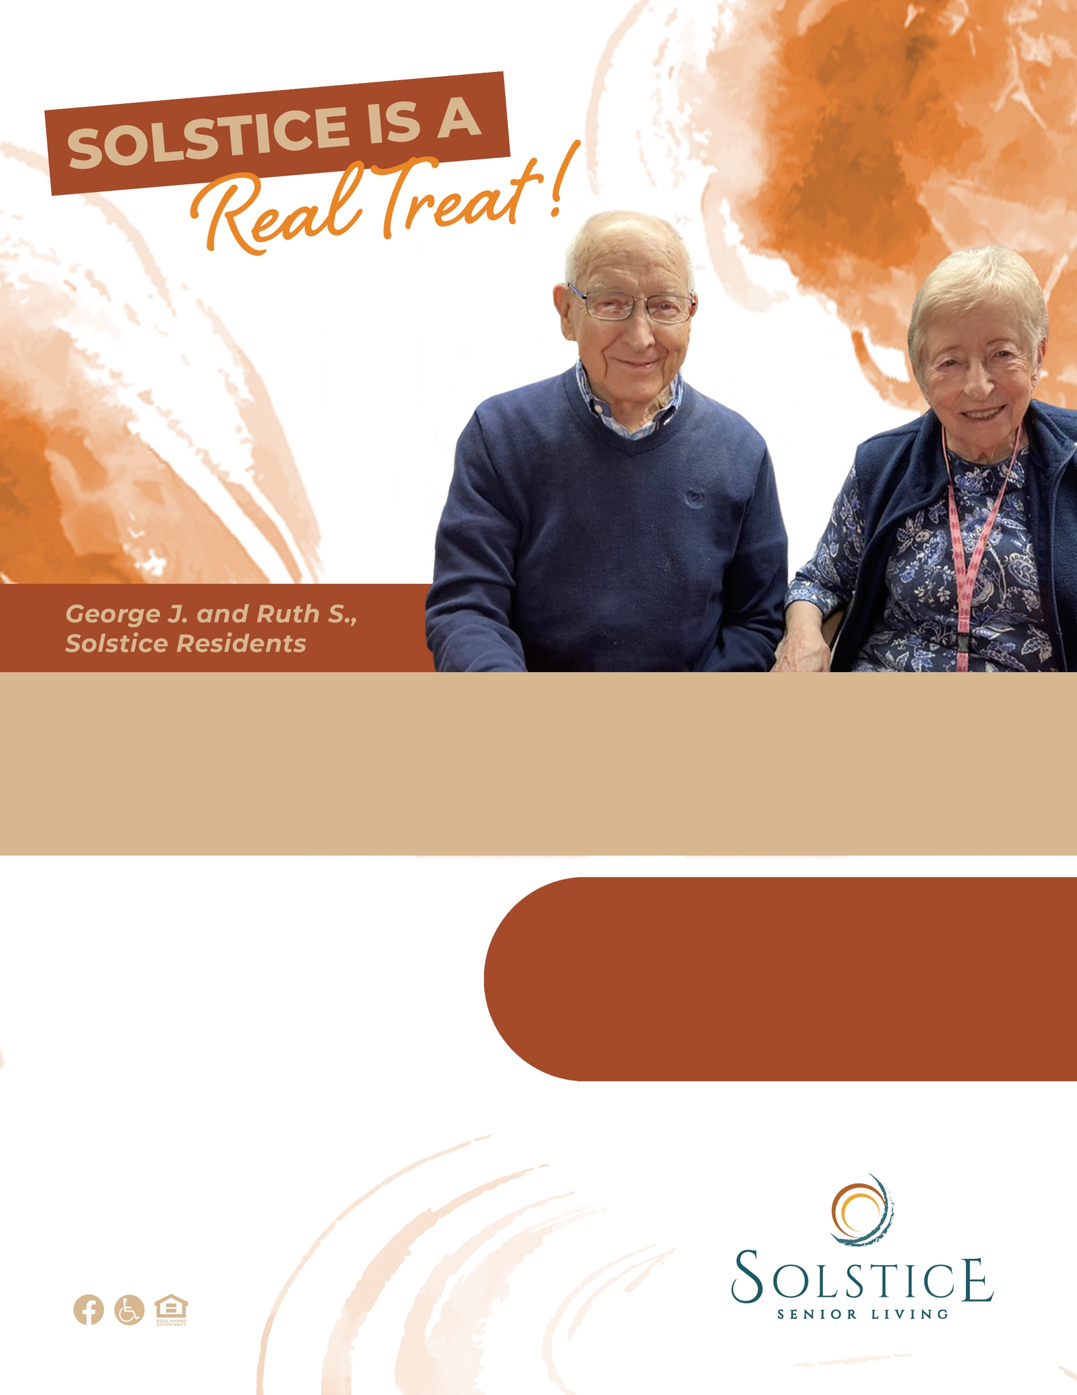­­

Solstice Senior Living at COMMUNITY

123 Address Street, City, ST 12345 | (XXX) XXX-XXXX

SolsticeSeniorLivingXX.com

New friendships and adventures can be found around every corner at Solstice Senior Living.

**Schedule your tour!**Call (xxx) xxx-xxxx to learnmore.

**Learn more about our   
community today!**