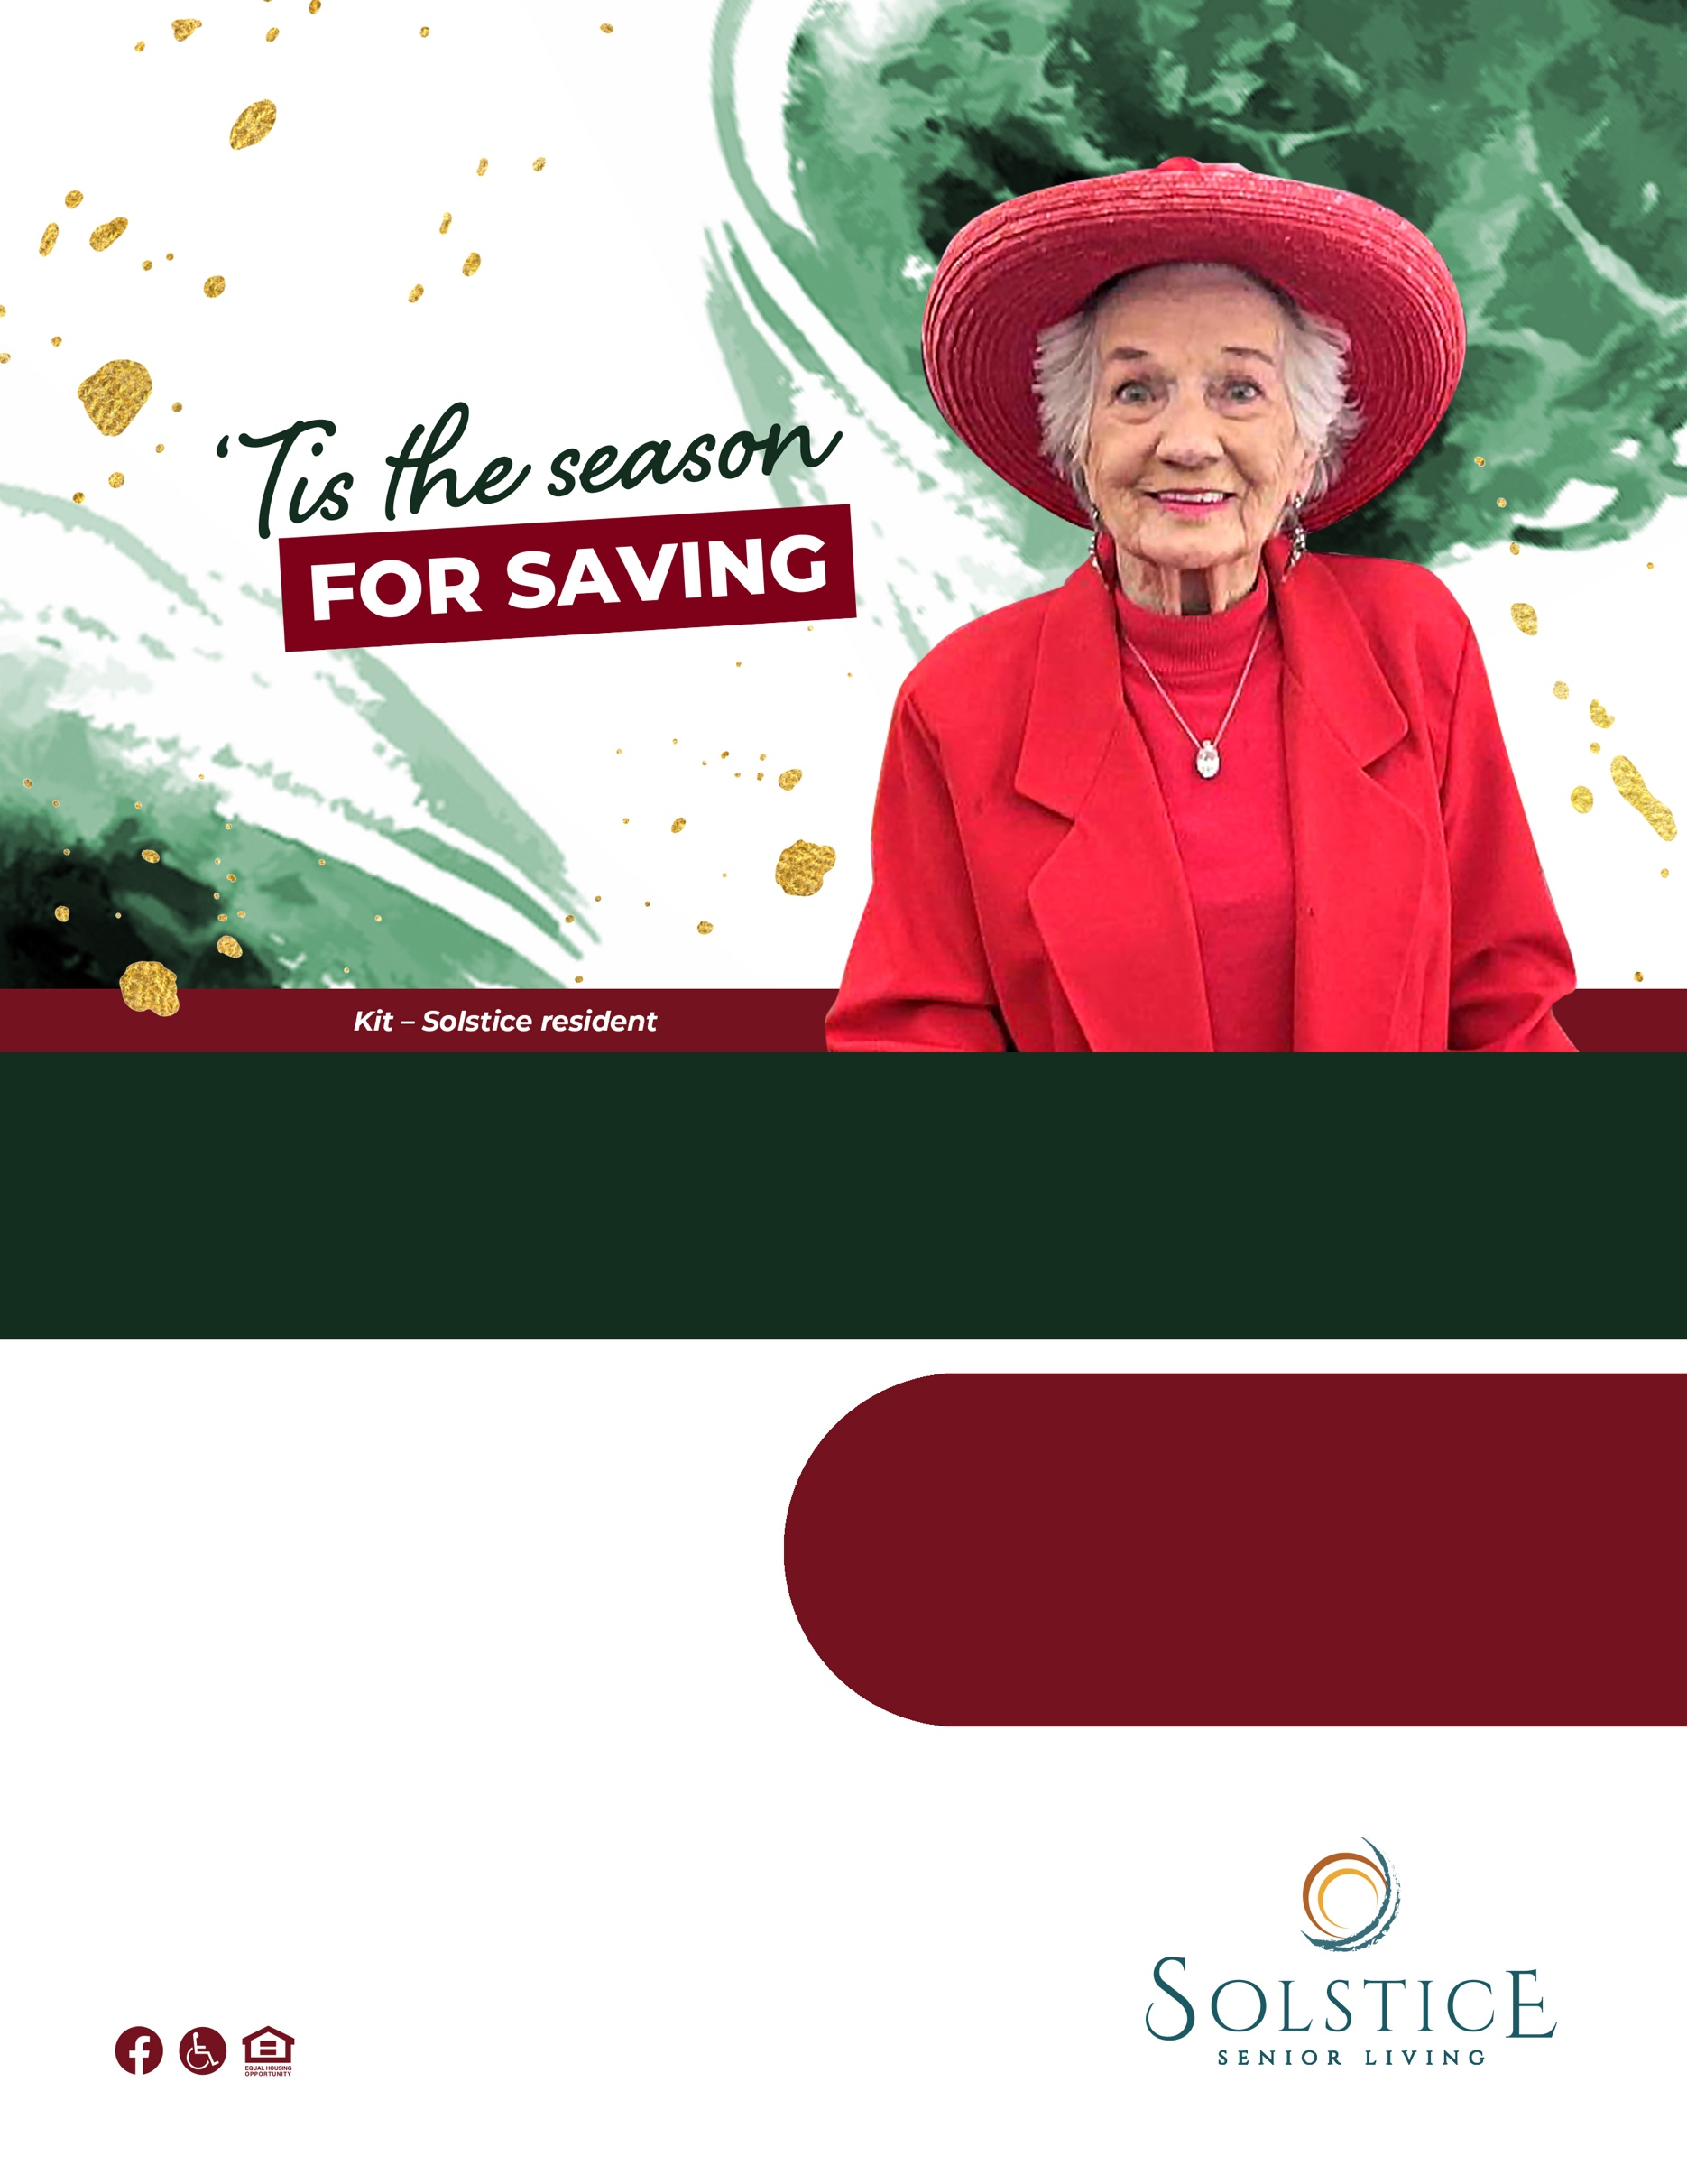­­­

**Save Thousands!**

Solstice Senior Living at COMMUNITY

123 Address Street, City, ST 12345 | (XXX) XXX-XXXX

CommunityURL.com

At Solstice Senior Living, we’re family. Join a community and experience a vibrant lifestyle with amenities and activities around every corner. Take advantage of our best offer yet.

**Save on rent when you join Solstice in December.\***\*Some conditions apply; call for details.

**Call us today to learn   
more about our offers!**  
(XXX) XXX-XXXX