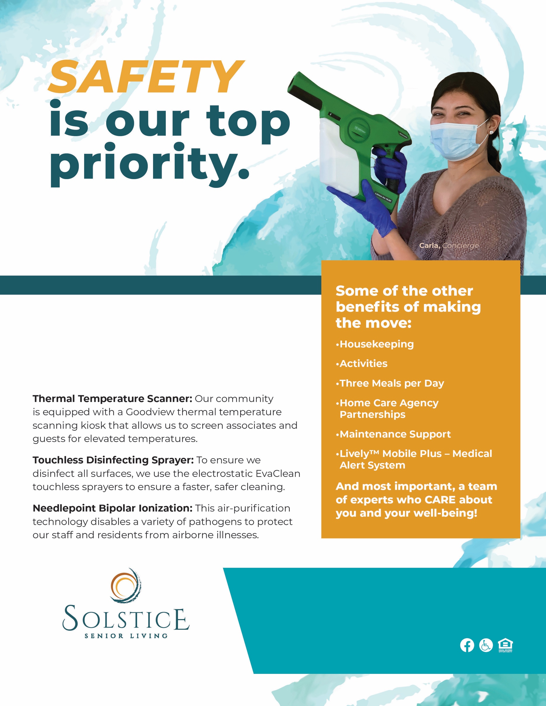

At Solstice at [Community], the health and safety of our residents is our top priority. Learn more about the protective safety measures we’ve implemented in all of our Solstice communities.

**Solstice Senior Living at [Community Name]**

XXX Address Street • City, ST ZIPCODE

Call us today at

**XXX-XXX-XXXX**

to find out more.